**DigiMesh DemoService WEB Service 結果展示**

1. 連線位置 :

* Web Service : <http://10.1.1.1:12800/BusinessServices/ServiceMediationService.serviceagent/ServiceMediationOperation> (SoapUI測試為例)

1. 連線資訊 :

**WebService (SoapUI測試為例)**

Request XML:

|  |
| --- |
| <?xml version="1.0" encoding="utf-8"?>  <soap:Envelope xmlns:soap="http://www.w3.org/2003/05/soap-envelope" xmlns:v1="http://www.iisigroup.com/magiclamp/common/soapenv.xsd/v1" xmlns:v11="http://www.iisigroup.com/xsd/TW/DemoService/OneToOneRq/v1">  <soap:Header>  <v1:Header v1:mustUnderstand="true">  <ChannelID>ESB</ChannelID>  <ServiceDomain>DemoService</ServiceDomain>  <OperationName>OneToOne</OperationName>  <ConsumerID>TWESB</ConsumerID>  <TransactionID>T1222222</TransactionID>  <RqTimestamp>2015-12-06T12:01:01.00+08:00</RqTimestamp>  </v1:Header>  </soap:Header>  <soap:Body>  <v11:OneToOneRq>  <v11:ServiceHeader>  <v11:TxnId>DO01</v11:TxnId>  <v11:TxnNo>DO010001</v11:TxnNo>  </v11:ServiceHeader>  <v11:Signon>  <v11:CustId>ESBUSER</v11:CustId>  <!--Optional:-->  <v11:CustPswd>123456</v11:CustPswd>  </v11:Signon>  <v11:ServiceBody>  <v11:RqTransform>  <v11:Pass>Y</v11:Pass>  <!--Optional:-->  <v11:ErrorCode>0903</v11:ErrorCode>  </v11:RqTransform>  <v11:InterfaceProxy>  <v11:Pass>Y</v11:Pass>  <!--Optional:-->  <v11:ErrorCode>0903</v11:ErrorCode>  <!--Optional:-->  <v11:TimeOut>5000</v11:TimeOut>  </v11:InterfaceProxy>  <v11:RsTransform>  <v11:Pass>Y</v11:Pass>  <!--Optional:-->  <v11:ErrorCode>0903</v11:ErrorCode>  </v11:RsTransform>  </v11:ServiceBody>  </v11:OneToOneRq>  </soap:Body>  </soap:Envelope> |

Resposne XML:

|  |
| --- |
| <tns4:Envelope xmlns:tns4="http://www.w3.org/2003/05/soap-envelope" xmlns:ns2="http://www.iisigroup.com/magiclamp/common/soapenv.xsd/v1" xmlns:tns14="http://www.iisigroup.com/magiclamp/common/genericsoaprequestprocessor_processvariableschema.xsd/v1">  <tns4:Header>  <ns2:Header>  <ChannelID>ESB</ChannelID>  <ServiceDomain>DemoService</ServiceDomain>  <OperationName>OneToOne</OperationName>  <ConsumerID>TWESB</ConsumerID>  <TransactionID>T1222222</TransactionID>  <TrackingID>5bef0ebc-6261-4f8e-a19c-7ef6b17dfbba</TrackingID>  <UUID>26db1466-fa20-41c4-8e43-019454a48543X1cDC1JYV1td</UUID>  <RqTimestamp>2015-12-06T12:01:01+08:00</RqTimestamp>  <RsTimestamp>2020-01-10T19:44:32.522+08:00</RsTimestamp>  </ns2:Header>  </tns4:Header>  <tns4:Body>  <tns2:OneToOneRs xmlns:ns="http://www.iisigroup.com/magiclamp/common/soapenv.xsd/v1" xmlns:tns7="http://schemas.xmlsoap.org/soap/envelope/" xmlns:tns1="http://www.w3.org/2003/05/soap-envelope" xmlns:tns22="http://www.iisigroup.com/magiclamp/pattern/onetoonerqrs/onetoonerqrsprocessvariablesschema.xsd/v1" xmlns:soapenv="http://www.w3.org/2003/05/soap-envelope" xmlns:tns18="http://www.iisigroup.com/magiclamp/pattern/common/patternonetoone01inputschema.xsd/v1" xmlns:xs1="http://www.iisigroup.com/xsd/TW/DemoService/OneToOneRq/v1" xmlns:tns25="http://www.iisigroup.com/magiclamp/pattern/common/patternonetoone01outputschema.xsd/v1" xmlns:tns3="http://www.iisigroup.com/magiclamp/abstractprocesses/rstransformoutputschema.xsd/v1" xmlns:tns24="http://www.iisigroup.com/magiclamp/abstractprocesses/rstransformoutputschema.xsd/v1" xmlns:tns2="http://www.iisigroup.com/xsd/TW/DemoService/OneToOneRs/v1">  <tns2:ServiceHeader>  <tns2:TxnId>DO01</tns2:TxnId>  <tns2:TxnNo>DO010001</tns2:TxnNo>  <tns2:SvcVer>v1.1</tns2:SvcVer>  </tns2:ServiceHeader>  <tns2:Signon>  <tns2:CustId>ESBUSER</tns2:CustId>  <tns2:CustPswd>123456</tns2:CustPswd>  </tns2:Signon>  <tns2:ServiceBody>  <tns2:RtrnCode>00</tns2:RtrnCode>  <tns2:RtrnDesc>Success</tns2:RtrnDesc>  </tns2:ServiceBody>  </tns2:OneToOneRs>  </tns4:Body>  </tns4:Envelope> |

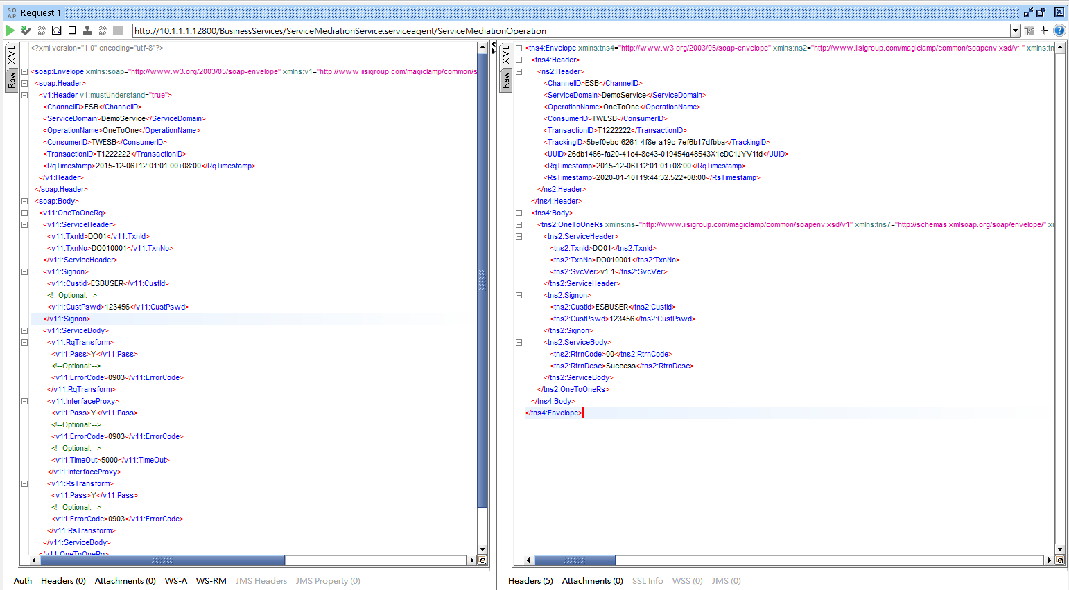

*Web Service連線圖例*